Systems Analysis for Process Automation and Innovation

# Executive Summary

This paper proposes an empirical analysis based on an interview with an employee at TLCTrucking, that is used to model the current As-Is situation using a BPMN Diagram. By carefully examining each departmental activity that is executed in the truck ordering process, alternative To-Be automation and innovation ideas are proposed.  Furthermore, it provides an analysis on the data flowing in and out of the company based on the relationships in TLCTrucking, then presents the construction of such analysis through the use of a Data Flow Diagram, along with ideas on automation and innovation. While similar, the ideas differ from the activity analysis and focus primarily on the improvements in the flow of data throughout the organization.

After both the processes and data flows at TLCTrucking have been represented, a comparative analysis is made. Differences lie in the stance the sub-teams take in composing these observations, by providing an understanding of ideas that are essentially matters of interpretation. In contrast, some ideas overlap that are minimally interpretive and nearly indisputable, such as what documents and databases are involved and how they are managed. Exploring the impact of the process on the organization, it indicates the significant impact on productivity, cost, and most notably on process time. Lastly, the paper provides the methods used and the importance of the assumptions made during the construction of the diagrams.

Highlights of potential changes are presented throughout the analysis of TLCTrucking ordering process. Areas of improvements considered include reducing overall process time, improving the flow of data, and minimizing labour-intensive tasks performed by stakeholders.

Table of Contents

Executive Summary 1

1. Context for the Study 5

2. Analysis using DFDs 6

2.1 Detailed Presentation of the As-Is situation 6

Data Verification 6

Data Validation 6

Data Availability 6

Areas of Special Interest 7

2.2 A Summary of To-Be Alternatives Considered 8

Table 1: Automation Alternatives based on DFD diagram 8

Table 2: Innovation Alternatives based on DFD diagram 9

2.3 Detailed Presentation of Two To-Be Alternatives 10

Figure 1: DFD diagram of Automation Alternative 10

Figure 2: DFD diagram of Innovation Alternative 10

Figure 3: ERD diagram of Innovation Alternative 10

3. Analysis using BPMN 11

3.1 Detailed Presentation of the As-Is situation 11

Areas of Special Interest 12

3.2 A Summary of To-Be Alternatives Considered 13

Table 3: Automation Alternatives based on BPMN diagram 13

Table 4: Innovation Alternatives based on BPMN diagram 14

2.3 Detailed Presentation of Two To-Be Alternatives 15

2.3.1 Automation Alternative 15

Figure 1: BPMN diagram of Automation Alternative 15

Figure 2: BPMN diagram of Innovation Alternative 15

Figure 3: ERD diagram of Innovation Alternative 15

4. Comparison of the Two Modeling Techniques 16

5. Methods, Activities, and Tools Used 17

Interview/Information Collection 17

Analysis 17

Tools 17

6. References 18

# 1. Context for the Study

### Organizational Overview

TLCTrucking focuses on on-going restructuring of company initiatives by continuously identifying client demands to provide client satisfaction. To improve communication with clients is a long-term goal for the company, along with improving social responsibility by building a strong reputation in the industry, and its effort to serving diverse markets. Being the market leader in an increasingly competitive and concentrated Canadian retail industry, this organization deals with various obstacles while performing its daily practices. This organization, as with other organizations in the industry, continues to use manual methods for work-related services.

The truck ordering process includes actors, physical objects, and information objects. Actors are the employees in various departments, and the physical and information objects include the documents, for example the application form and company document, and the electronic records that store data on the client and trucking inventory. The process being examined in this analysis is cross-departmental. Precisely, the stakeholders involved are two departments within TLCTrucking including the Transportation department (Transport) responsible for the delivery and maintenance of the trucks in the system, and the Central Data Maintenance department (CDM) who has access to client information.

### Organizational Objectives and Stakeholder Goals

The lack of automation for this company results in time-consuming processes that interfere with overall productivity. To name a few, the existing process relies heavily on manual checks done by CDM to verify the incoming data from clients into the company. Transport has to manually re-enter submitted requests into an internal software to process truck orders. The current procedures taken by the client to submit their order request is demanding and prone to errors.

Inadequate understanding of how data should flow from the beginning to the end of the process leads to additional effort by TLCTrucking departments. Transport department sends and receives information from the client, when CDM’s main role is to act as a liaison between the client and the organization. Verifying, validating, and checking data availability are critical tasks in the current process. Roles are poorly being identified and understood while executing these tasks, which result in a drain on the knowledge and skills each department has accrued.

Following hypotheses regarding improvements on organizational objectives were derived from analyzing the end-to-end TLCTrucking ordering process. Ideas on automation and innovation provide the organization with functional changes that can reduce overall wait time. Using computer-based information systems, activities conducted manually by CDM and Transport will be eliminated. By implementing database management systems, the flow of data will be improved throughout the organization, ensuring accuracy in information exchange within departments. The lack of cross-departmental and interdepartmental communication slows down the client’s ordering requests. Implementing tools to allow instant interaction will strengthen communication and maintain an efficient flow of information.

### Quantitative Figures

Based on the interview conducted, information regarding the client was made note of. Being the market leader in retail and owning thousands of trucks on hand, TLCTrucking on average receives approximately 800 client requests per day (all facilities combined). The client waitlist queue can hold up to 3000 client requests at a time. Tasks associated with requests over maximum capacity of the queue is out of the scope of the process being analyzed. The estimate time spent on processing each client request is approximately 3 hours (CDM and Transport contribution combined).

# 2. Analysis using BPMN

## 2.1 Detailed Presentation of the As-Is situation

This section of the paper analyzes in detail the As-Is process of ordering a truck at TLCTrucking.

Along with the various events that take place, the process includes actors, physical objects, and information objects (as seen in Figure 3.1). Actors are the employees in various departments, and the physical and information objects include the documents and electronic records that store data on the client and trucking inventory. The process being examined in this analysis is cross-functional. Precisely, there are two departments involved including the Transportation department at TLCTrucking responsible for the delivery and maintenance of the trucks in the system, and the Central Data Maintenance department who has access to client information.

The process starts by the client wanting a truck from TLCTrucking to relocate products from point A to point B; distribution center to facility. They request a new application form on the TLCTrucking website.The application downloads as a PDF form onto the client’s computer, and the client opens the form and fills in the required information. Some critical information needed is the client ID, name, location, and requirements for the type of truck, for example a truck that can hold a weight of 1500 kg. Once the form is completely filled out (on the computer or by hand), the client attaches the form in an email and sends it out to the Central Data Maintenance department at TLCTrucking.

The Central Data Maintenance department receives the email with the attachment. The form is printed out and the barcode is scanned, which is located at the bottom of the form. This step is to collect client information into the company database for record keeping. CDM first checks if the client is new or existing in the system based on the information provided on the application. If the client is pre-existing in the system, the request is sent to Transportation team, otherwise a new client is added to the system and the request is sent to the Transportation team. CDM then checks the form provided by the client and assures completeness. If the information on the form is invalid, it is sent back to the client to update. The request then goes through this loop again where it starts from CDM assuring completeness until the form is valid. The significance of sending the request back to the client to update is to prevent fraud and any misunderstandings between the client and the delivery. If the information on the form is valid and completely filled out, CDM manually types in the information from the form onto the Company Document which contains the signature of the employee responsible for sending the document over. The Company Document is then sent to Transport.

The Transportation department at TLCTrucking receives the email with the Company Document. Transport continues to process the request by checking for an available truck specific to the client’s needs stated on the document under “Type”.  This computer-based interface that links to the trucking inventory us called “IsoTrak” which organizes, stores, and communicates information on truck availability to Transport. The check is done by selecting the specifications through a set of drop-down menus. For example, if the client requires a truck for relocating their dairy products, then a truck that includes built-in cooler is mandatory, so the products stay fresh. If there is a truck available matching the conditions, Transport sends a quote providing complete information on the type and cost of the truck to be approved by the client. The client reviews the information and can either accept or decline price of the offer. If declined, an email is sent, and the request is terminated, otherwise the client sends an email message back to TLCTrucking and the client ID is added next to the truck in the truck rental database by transport and the request is complete. The truck is checked out of the system and the process is complete.

In the case where there is no available truck in the system that matches the conditions, Transport adds the client ID in the system next to the type of truck. Depending on how many client ID’s have been previously entered the client is assigned a number. For example, if there are 20 different client ID’s that are added to the queue previously, the next ID added would be assigned number 21 in queue. Here the First-In-First-Out (FIFO) approach is used, given there is no priority queue. When it’s time for the client to leave the queue, the client ID is added next to the truck, the truck is checked-out from truck rental database and the process is complete.

### Areas of Special Interest

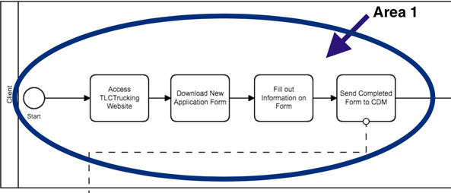Many areas require special attention after carefully examining the truck ordering process at TLCTrucking. The first area is marked on Figure 3.1.1. As described above the process involves the client to first go on the TLCTrucking website, then to request a new application form where they fill out the information and attach the form in an email and send it to the CDM department. This task is labour-intensive as it requires the client to conduct multiple steps only to have one request made.

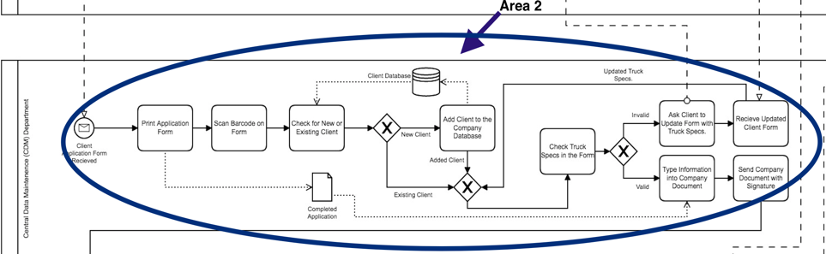The second area of special interest is marked as 2 on Figure 3.1.2. The Central Data Maintenance department receives the form, prints, and scans it. First checks if the client is new or existing in the system based on the information provided on the application. If the client is pre-existing in the system, the request is sent to Transportation team, otherwise a new client is added to the system and the request is sent to the Transportation team. CDM then checks the form provided by the client and assures completeness. If the information on the form is invalid, it is sent back to the client to update. If the information on the form is valid and completely filled out, it is typed on the form onto the company document. Transport receives this document. It requires when CDM manually types the information on the company document, they may mistype the client information. In doing so, Transport could be unaware and further problems could take place when processing the request.

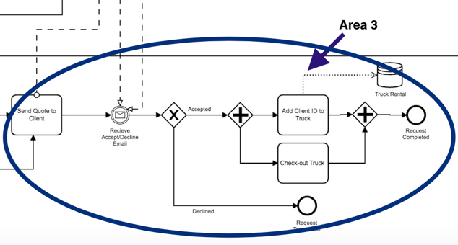Another area of special interest is marked as 3 in Figure 3.1.3. After truck requirements have been met, the client receives a quote from transport which contains the type specifications and cost of the truck. The client then has the choice to accept or decline the offer based on the cost of the truck. There are emails going back and forth in this area of the process where communication via email slows down the process. First waiting for Transport to send the quote, then the client taking time to either accept or decline and when the decision is made, the client has to send an email back to Transport to secure the truck or reject the offer. Transport then needs to take actions depending on the decision made by either checking out the truck from the truck rental database or terminating the client request.

### Figure 1: BPMN diagram of As-Is process

### Figure 2: ERD diagram of As-Is process

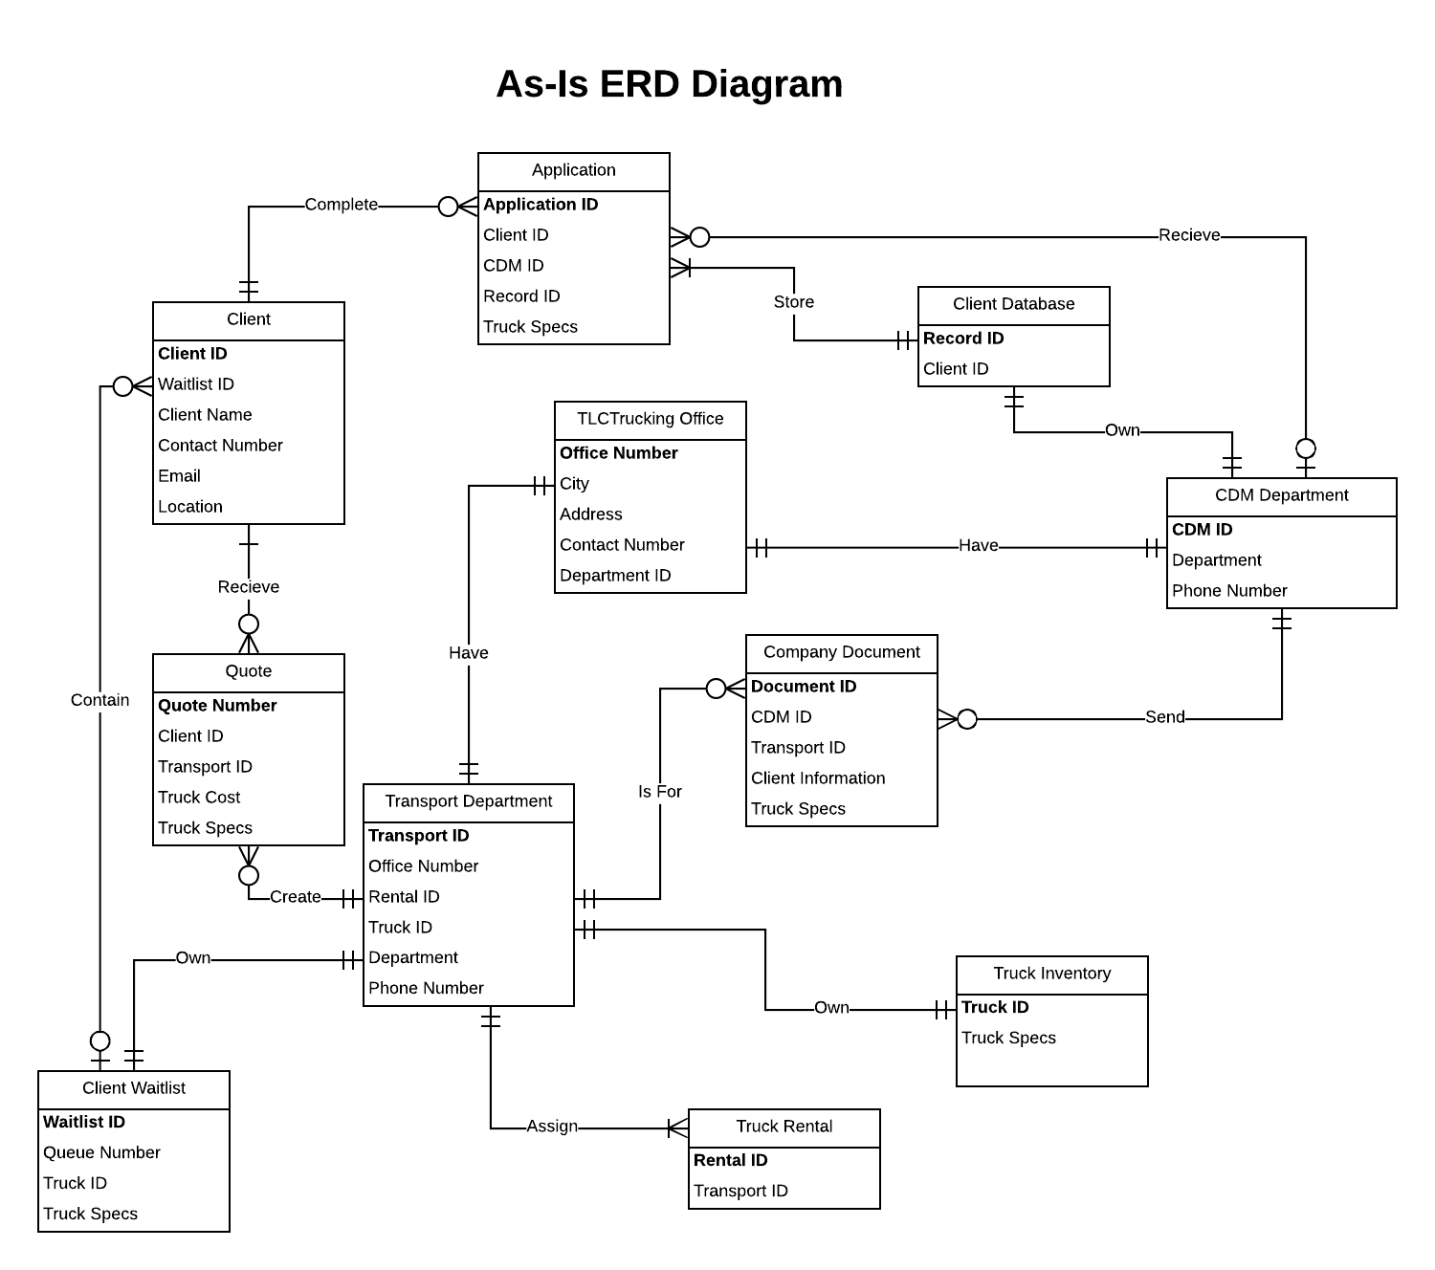

## 2.2 A Summary of To-Be Alternatives Considered

Tables 1 and 2 summarize automation and innovation alternatives derived from analyzing the BPMN diagram.

### Table 1: Automation Alternatives based on BPMN diagram

|  |  |  |
| --- | --- | --- |
| Automation | Pros | Cons |
| To speed up the process time, the client will be provided with an online form on the TLCTrucking website where they would fill their information along with their request details. Once this form is submitted by the client, the information will be accessible by CDM. | * Faster information exchange. The client information can be accessed directly on the website by CDM as soon as it is submitted. The wait time is reduced by eliminating information transfer through email. * Accurate information entry. This will decrease the number of errors provided on the form as handwritten applications can have a number of errors. * Ease of information handling. CDM would not need to keep record of all the emails sent and received from the clients. | * Can lead to unauthorized users filling out the online form. This will result in inaccurate information going into the company. * Using an online method of receiving clients’ requests is not reliable. In an instance where the website is down, no client will be able to submit their request. |
| Once the client information is verified by CDM, the truck specifications identified in the client form can be automatically transferred into an internal document, removing the company document that is manually filled by CDM. | * Decrease manual work. This will eliminate the process of CDM manually entering the client requested truck specifications into an internal document. * Reduce human error - The chances of CDM typing and processing incorrect truck specifications will be reduced as there will be no human input involved in the process. | * Difficulty in modifying the truck specifications after the client submits their request. If the client wish to modify their request, further communication between the client and TLCTrucking departments will be needed. |
| To automate the process of sending quotes and reduce the time spent waiting for client’s response, an estimate cost can be provided to the client when they fill the online application. The cost will be based on the truck specifications identified by the client. | * Remove unnecessary information exchange. The estimated truck cost will be based on the client request and truck specifications. This process will automate the existing information transfer protocol and cut down the overall process time. * Efficient end-to-end process. By providing the client with the cost earlier in the process, TLCTrucking will save the time and effort put on incomplete requests. | * Transport has record of the emails sent with the quote when they send it to the client directly. After this step is automated, transport no longer is aware if the client has received the cost. If the client did not view the cost and decides to process the request, in the end the request may need to be cancelled. |

### Table 2: Innovation Alternatives based on BPMN diagram

|  |  |  |
| --- | --- | --- |
| Innovation | Pros | Cons |
| Redesigning the TLCTrucking website to allow the client to submit their request online and accept or decline the offer. | * Minimize departmental activities. CDM’s activities will be reduced to only validating the correctness of the client request. Transport will be responsible for checking inventory of the trucks and notifying the client through an automatic message. * Reduce human errors. Using drop down menus with set options can make the process less prone to mistakes. | * If the website is down, the client will have to wait for the issue to be resolved which results in loss of productivity for the company. |
| Merging activities from both CDM and Transport departments to streamline the process. Handing off the activities performed and managed by the Transport department to CDM department. | * Reduce inter-departmental tasks. By merging both departments, the overall process time will be reduced as the client will be informed directly by CDM when the request is being processed. * TLCTrucking will save costs when colliding teams by reducing overhead. | * More tasks will be handed off to the employees in the CDM department. |
| Introducing a computer-based information system which is fed with clients’ requests (truck type and specification). This system will process the request, check for available trucks, add clients to waitlist, and notify clients with cost once the requested truck is available. | * Reduce labour work. Transport’s activities will be eliminated as the client’s request will be processed by the introduced system. Less employees will be involved in the truck ordering process, saving TLCTrucking money. * Improve the order handling process. The information system will enhance the order processing step and reduce the overall time spent from both the client’s and TLCTrucking’s sides. | * The new system has minimal supervision. This can be an issue when modifying submitted requests. |

## 2.3 Detailed Presentation of Two To-Be Alternatives

### 2.3.1 Automation Alternative

This section will analyze the To-Be automation idea, modeled in **Figure 2.1**. The chosen idea focuses on providing the client with an online form on the TLCTrucking website. This form can be completed by providing truck ordering details and client contact information. Once submitted, CDM will have instant access to the specified details. Labor-intensive work will be minimized by both the client and CDM. The client will no longer need to manually input their requests. Thus, CDM will reduce the time spent processing submitted requests, which are performed currently by manually printing, scanning, and checking completed forms.

By cutting down the time spent on filling out an order request, there will be a notable significant increase in the number of request forms submitted. Not only that, the forms submitted will have minimal to no errors as the client will be provided with pre-set truck specification options to select from. This will eliminate human errors and improve the quality of submitted information.

Like any online form filling process, unauthorized personnel can complete and submit an order request. This will result in adding more activities to CDM department in which a designated employee will have to check the validity of submitted requests before adding new clients to the database. In addition, modifying incorrect submitted contact information included in the application forms will be challenging. More activities will be required by CDM and the client to identify and overcome this issue.

The new BPMN diagram presented in **Figure** contains a new activity which replaces the existing activities performed by the client.  In the As-Is process, client performs the activity of downloading the application form, filling out that form, attaching the form to an email, then submitting the request by sending an email to CDM. The To-Be diagram removes this chain of activities and replaces them with a single activity where the client submits an online application form. Automating the current procedures taken during the execution of the truck ordering process, will prove the hypothesis of which improvements to the existing process at TLCTrucking will impact the organization in terms of productivity, cost, and process time.

### Figure 1: BPMN diagram of Automation Alternative

### 2.3.2 Innovation Alternative

This section will analyze the To-Be innovation idea, modeled in **Figure 3.1**. The chosen idea focuses on redesigning the current TLCTrucking website to improve the procedures taken by the client to process their request. Implementing control relocation by removing some departmental activities (activates done by CDM and Transport) and streamlining them by integrating the TLCTrucking website as a part of the ordering process at TLCTrucking. Redesigning the TLCTrucking website to allow client access, will enable clients to update their profile and submit their rental request. The implementation of the new website will reduce overhead as it removes the use of multiple departments by having only those who use the output (such as the client) perform majority of process. In order to ensure completeness and accuracy, the system will not allow the client to submit the form unless all information is filled in and completed.

By minimizing both CDM and Transport manual tasks, the redesigned website will act as the foundation in streamlining TLCTrucking. As such, both the company and the client will be highly dependent on the restructured website. Completely modernizing the process will assist in improving the company’s productivity. The overall truck ordering process will be performed and processed much faster than the As-Is situation. Thus, increasing client satisfaction proving the hypothesis in which the innovation idea has an impact on TLCTrucking reaching the anticipated objectives. Systems replacing human workers could be threatening. Automating the process does not necessarily mean completely improving it. Depending highly on the system is a major downside where for an instance if the website goes down, the whole process will be paused resulting in loss of productivity for the company.

Shown below is the To-be innovation BPMN diagram. TLCTrucking website is introduced as a new lane inside TLCTrucking pool as the website is internal. Most tasks that were originally executed by CDM and Transport, will now be completed on the website. Multiple iterations and refinements were performed on this diagram allowing to better state the described idea. Overall, an improvement in the process time and a reduction in the number of manual activities are being noticeable.

### Figure 2: BPMN diagram of Innovation Alternative

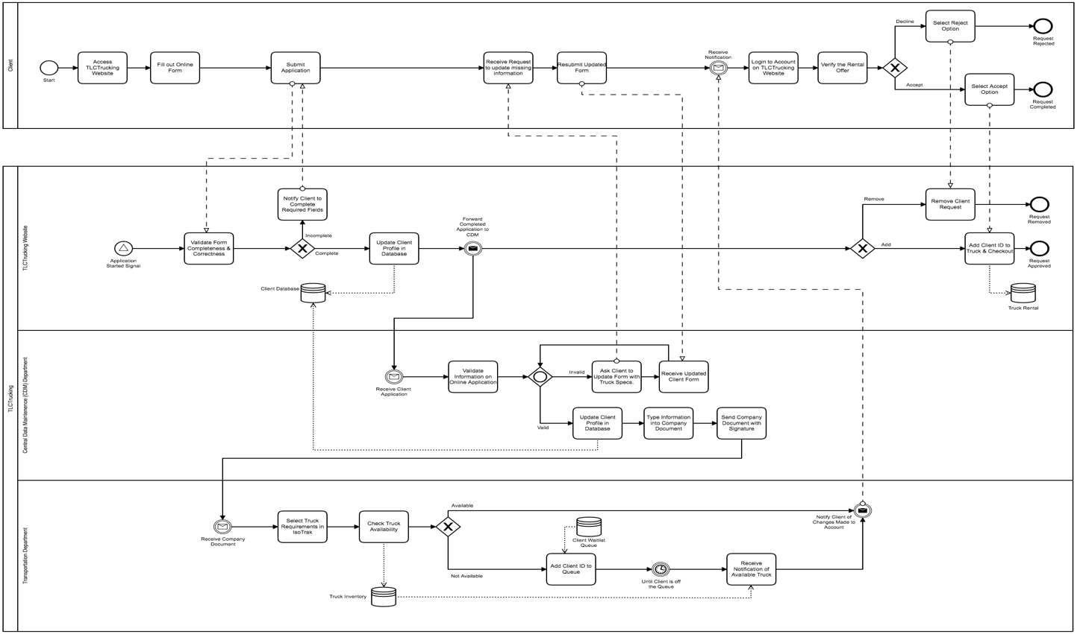

### To-Be Innovation ERD

A question surfaced during the modeling of the ERD: All clients receive notifications from the Transportation department regarding their requests, and the Transportation department sends many notifications to each client - but how can we resolve this many-to-many relationship for a more accurate assessment? By facilitating a solution in which the client receives one or more automatic notification (a newly introduced association entity) allowing a one-to-many relationship between the client and notification, and many notifications are being sent by only one Transportation department.   The ERD diagram presented in Figure .. shows the relationships between the entities within the process including the newly introduced association entity (Automatic Notification). Modeling this ERD diagram helped in identifying the relationship between client and Transport department. BPMN model was refined accordingly to include the notification flow from Transport to client.

### Figure 3: ERD diagram of Innovation Alternative

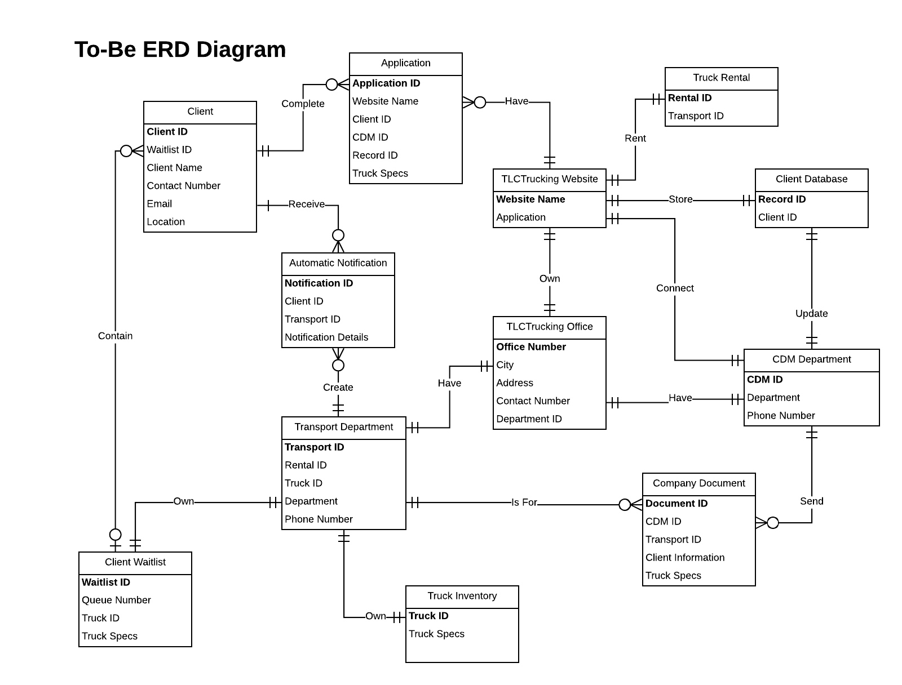

# 3. Analysis using DFDs

## 3.1 Detailed Presentation of the As-Is situation

This section of the paper analyzes in detail the As-Is process of ordering a truck at TLCTrucking from a data perspective.

The process begins when the client decides to order a truck. The TLCTrucking website is accessed and the application form is downloaded onto the client’s computer. The client fills in personal information such as client ID (specific to each rental), name, location, and type specifications of the truck. This information is then sent to the Central Data Maintenance department at TLCTrucking. Such information about the client comes into the business. This data is being transferred from the client to CDM through email.

### Data Verification

CDM prints the application received and scans the barcode. By scanning the barcode, which is located at the bottom of the application, TLCTrucking internal company application determines whether the client is new to the company or pre-existing. TLCTrucking internal company application is connected to client database in which the data is being stored. This database stores client data (ID, personal details). This database allows CDM to add a new client or update information on a pre-existing client. To enter data or customize fields in the database, CDM logs into TLCTrucking internal company application.

### Data Validation

In the case when CDM adds a new client to the client database, it is responsible for validating any discrepancies in the application provided. CDM evaluates each new client based on set requirements such as their client ID, given each client has a client ID provided by their organization. CDM verifies the identity of the client’s corporation and their contact information; authorized email and number.

Once the client information is validated, CDM checks whether the truck specifications that are provided on the client application is valid or not. In case the specifications do not match those in TLCTrucking’s inventory, the request is sent back to the client to update. This process of data coming into and out of the company continues until truck specifications on the application are valid. Once the specifications match with any of the specifications identified in TLCTrucking’s inventory, an internal document is manually created by CDM to include the client information (client ID, personal details) and truck specifications (truck type, duration). Due to internal company policy, CDM employee’s signature is required on the completed company document. This document is being sent through email to Transportation department in order to process client’s request.

### Data Availability

Transportation department at TLCTrucking receives the company document that is emailed by CDM department in the form of an attachment. This company document contains information on the client details and truck specifications. Transport uses the data provided on the document to search into the company inventory through IsoTrak (an interface that connects the employee working at TLCTrucking to the truck inventory database). The truck inventory database contains all inventory information, for example how many trucks of which type are currently on hand in the company. This type of information allows Transport to make a decision on whether the requested truck is available or not. In the case when the requested truck is not available, client ID along with the requested truck ID are being added to client waitlist database. This database stores the outstanding requests until the requested trucks are available to order.

Once the client’s requested truck is available, a quote is being sent to the client through email by Transport. The quote includes data on truck specifications, cost, and TLCTrucking company information. The client receives the quote and decides whether or not they would like to proceed with the order. An email stating the decision of the client is being sent back to Transport. This email includes client ID, client’s decision, contact information, and the quote being accepted or rejected. Once presented with client’s decision, Transport would assign the client ID to the Truck ID stored in truck rental database if the quote was accepted. Truck inventory database would be updated accordingly to include the trucks being checked out.

### Areas of Special Interest

There are areas that require special attention and issues that are identified with the process. The areas that are identified when assessing the As-Is situation based on the DFD diagram (Figure 4.1) include the process of CDM validating the truck specifications present on the client application. The Central Data Maintenance (CDM) department checking This process is time consuming and involves data to enter and leave the company. This manual storing of data, adding a new client or updating a pre-existing one, requires multiple steps to take place. Identifying opportunities for improving data collection and analysis, increasing availability of client data by allowing access by departments within TLCTrucking, and ensuring data accuracy.

Information currently flows through departments at TLCTrucking. The interface connecting the Transport department to the truck inventory organizes, stores and communicates truck information to Transport only. Due to the privacy & confidentiality policies of the organization, the client is unable to access the data in the inventory database. Data regarding the availability, type of truck specifications (such as built-in features) are not presented to the client. The client waits for their request to be processed by Transport.

### Figure 4.1: Context Diagram of As-Is DFD at TLCTrucking

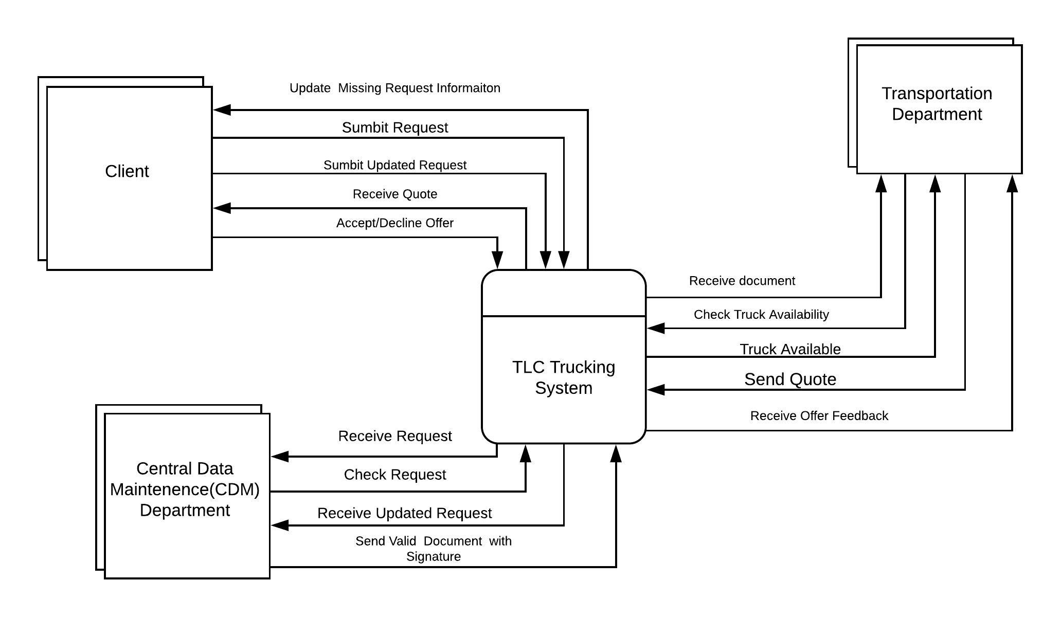

The data flow diagram (DFD) in Figure 4.2 represents the relationships between entities and displays the flow of data through the entire process, in hand with determining how organizations objectives are achieved. This diagram helps to understand the use of data in each activity by visually depicting the relation between the data and processes.

### Figure 4.2: Level 1 Diagram of As-Is DFD at TLCTrucking

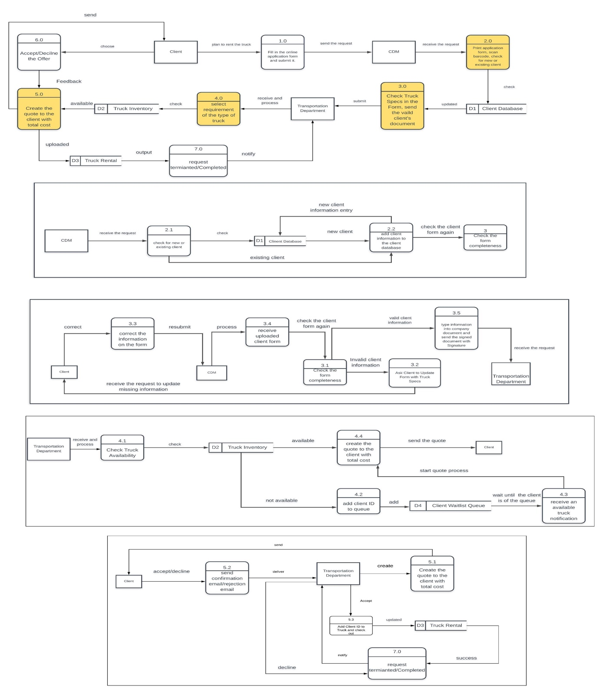

## 3.2 A Summary of To-Be Alternatives Considered

Tables 3 and 4 summarize automation and innovation alternatives derived from analyzing the DFD diagram.

### Table 3: Automation Alternatives based on DFD diagram

|  |  |  |
| --- | --- | --- |
| Automation | Pros | Cons |
| From the data perspective, the company document that CDM creates with client details and truck specifications  that is delivered to the Transport department can be removed and the process of data transfer can be done in a system that connects both CDM and Transport, and not via email. | * Available for both departments within TLCTrucking, access of this online document allows for faster information flow. * Reduce documents (physical and electronic) floating through email around the company. | * TLCTrucking would not have each client’s request form if there is no company document. If the system that connects CDM with Transport is down, there is no record for this request being approved and processed. |
| Automatically provide data by allowing information such as the cost and truck availability to be accessible by the client early in the process. A table with the data will be added to TLCTrucking’s website. | * This change in the flow of data out of the company will allow the client to immediately access information without having to submit a request and wait to get notified. * Reduce the quote documents that are transferred to the client through email. | * The information presented to the client might not be accurate at this point in the process. There might be data latency between checking out trucks and table update. |
| The client will be provided with an online form on TLCTrucking website that can be used to submit their contact information and truck specifications. If the client is pre-existing, the website will automatically process the request instead of CDM. | * Quick flow of data into the company while minimizing data checks done by CDM | * Only pre-existing clients can have their request processed automatically. New client request will continue to follow the existing process (CDM checks the request manually) |

### Table 4: Innovation Alternatives based on DFD diagram

|  |  |  |
| --- | --- | --- |
| Innovation | Pros | Cons |
|  |  |  |
| A system in the Transport department that analyzes data based on previous information retrieved from the truck inventory database and client waitlist queue can automatically predicts the wait time for the truck rental.  For example, based on previous data the system can immediately predict when the truck will be available to the client. | * Immediately estimates the wait time of truck availability. The client will know beforehand how long will it take to receive the requested truck. | * Prediction may not be accurate due to external factors. |
| Communication is limited between TLCTrucking departments. VoIP PBX phone systems can be introduced to enhance communication between departments. | * Better communication will improve efficiency and effectiveness in processing clients’ requests. It allows CDM and Transport to instantly contact when questions arise regarding client requests. | * Departmental dependency. Relying on departments to answer client related questions can be time consuming. |

## 3.3 Detailed Presentation of Two To-Be Alternatives

### Figure 1: DFD diagram of Automation Alternative

### Figure 2: DFD diagram of Innovation Alternative

### Figure 3: ERD diagram of Innovation Alternative

# 4. Comparison of the Two Modeling Techniques

### BPMN Evaluation

Various annotations are being used in BPMN to identify the end-to-end business process flow. It explains the truck ordering process from an activity and task perspective. Tasks that need to be done by CDM, such as creating the company document, are shown on the diagram. Pools in BPMN set the boundaries of the business process providing a clear representation of the relationship between departments. The manual tasks taken by the client to make a request (such as download the form, fill out the form, attach the form) is shown in detail on the diagram as compared to the DFD where there is one process that represents the client filling out and submitting the form. By visually depicting detailed sequences of business activities, the process. This diagram is easier to understand from an outsider as it shows the activities done by each department in detail and the interaction with the client.

The BPMN diagram that represents the truck ordering process depicts some information flows in terms of databases, such as the client database, truck inventory database, and the truck rental database. Data objects such as company document but does not represent the actual flow of this data from entity to entity. The diagram for TLCTrucking clearly includes all kinds of stakeholders. Looking at the activities in the BPMN, it is clear where automation and innovations ideas can be derived from. The areas with multiple gateways and activities done by one department determines what activities can be minimized by the implementing various techniques mentioned and further understanding how they will affect the process as a whole. It shows us the wait time required for the activities to be done, it becomes easy to determine the places we can improve and eliminate the time wait.

### Data Flow Diagram (DFD) Evaluation

DFD represents the flow of data between company’s information systems in a form of entities. The data is being moved from the external entity into internal entities and is stored in databases identified throughout the process using the rectangular notation.

Modeling the context diagram provided a higher level overview of the entities involved in the process. This helped in identifying the data coming in and out of each entity and their relationships including the relationship between external entity and TLCTrucking as a whole. The DFD on TLCTrucking has helped understanding the data flow throughout the process from entity to entity. It explains in details the information the client needs to provide and how this information is passed to the CDM department. It also explains in details the process the company uses to record and save the information and data provided by the clients to further use it to make accepting or rejecting decisions. It presents how the data is validated from the data flow perspective, along with the different departments that communicate together to process the data.

In addition, an indication of how long data takes to flow from one entity to another can’t be identified in this model. DFD area of special interest looks at the entire company how the data is flowing not just particular areas in the process.  This DFD model aims towards the information system and therefore hardly recognizes different stakeholders in the business process. Upon receiving information and producing the resulting outputs, this DFD model presents areas within a system where information is stored (client database and client information). There’s no starting and ending point for the data flow, which makes it difficult to follow and identify areas of weaknesses.

Because these DFD diagrams shows the flow of the data, it is easy to highlight the areas of improvement. Automated software can be added to minimize the manual flows of the data. It also makes it easy for us to understand how this software can work to fasten and improve the data flows (by redesigning the flows or creating new ones). Because this DFD model shows the information flow in the company, finding alternative information handling procedures can be done which would help design new information services.

Limitations  
Both the BPMN and DFD diagram for TLCTrucking fail to represent what data is in the process is important and worth storing. Client data is put under one category called “client information”, but the actual data contained in the client information is missing. Fails to explain why each activity or data flow is performed, by solely focusing on what happens during the process but not each of these process is done.

# 5. Methods, Activities, and Tools Used

Below are the methods along with insights and limitations faced during the execution of the analysis.

### Interview/Information Collection

An analysis based on an interview, with an employee who works for the Transportation department as a Transport Analyst for 7 years, is used to evaluate the hypothesis that the current process at TLCTrucking impacts the organization in terms of productivity, cost, and process time. Questions regarding the objectives and the procedures taken during the execution of the truck ordering business process were asked and made note of.  A rough sketch of the business process model was made while the steps and impacted departments were discussed in detail to help assist the analysis. During the interview process, limited information about the company’s documentation, policies, and overall process was provided due to confidentiality.

### Analysis

After gathering information about the industry and investigated process, a detailed analysis was conducted by the group from both the activity and data perspectives. Pain points were identified along with areas of weaknesses and strengths in the as-is process. Further analysis was conducted on areas with missing information. Assumptions were made in those areas in order to better capture and explain the overall process. For example, TLCTrucking’s internal document, which is the company document mentioned throughout the analysis, contains confidential company information. Due to this restriction, some assumptions were made regarding what information is including in the document. The private company interface (for accessing client information) was not accessible by the employee interviewed. Due to that the interviewee was not aware of the information contained in the client database.

### Tools

Software tools were used to assist in providing detailed explanation of both the existing process and the proposed improvement ideas. These tools include Camunda and Lucidchart. Camunda was used to create the BPMN diagrams and Lucidchart was used to create the DFD and ERD diagrams. BPMN annotations are provided in Camunda which helped in creating the diagram. However, Lucidchart had a restriction of 60-elements per project for non-subscribers. This limitation required the sub-team working on DFD to split the diagrams into multiple files.

# 6. References

Advantages Vs Disadvantages of DFD's... (2013, March 07). Retrieved from https://eternalsunshineoftheismind.wordpress.com/2013/02/20/advantages-vs-disadvantages-of-dfds/

B. (2010, November 08). The Problem with BPM Flowcharts. Retrieved from https://isismjpucher.wordpress.com/2010/10/04/the-problem-with-bpm-flowcharts/

Bleisch, S., & Nebiker, S. (n.d.). Working Principle of a Database Interface. Retrieved from http://www.gitta.info/DBSysConcept/en/html/DBLanguages_learningObject2.html

Bleisch, S., & Nebiker, S. (n.d.). User Interfaces. Retrieved from http://www.gitta.info/DBSysConcept/en/html/DBLanguages_learningObject3.html

Business Analyst Community & Resources | Modern Analyst. (n.d.). 5 Key Benefits of Business Process Modeling. Retrieved from https://www.modernanalyst.com/Resources/Articles/tabid/115/ID/1728/5-Key-Benefits-of-Business-Process-Modeling.aspx

Business Analyst Community & Resources | Modern Analyst. (n.d.). The Modern Analyst Blog for Business Analysts. Retrieved from https://www.modernanalyst.com/Community/ModernAnalystBlog/tabid/181/ID/1260/Why-I-Dont-Use-BPMN.aspx

Dumas, Marlon, Marcello La Rosa, Jan Mendling, and Hajo A. Reijers. Fundamentals of business process management. Heidelberg: Springer (2018). ISBN: 978-3-662-56509-4 (Online) https://doi-org.myaccess.library.utoronto.ca/10.1007/978-3-662-56509-4   (Referred to as DLMR in the course schedule.).

Kendall, K. E. and Kendall, J.E. Systems Analysis and Design. 9th ed. Pearson Prentice Hall, 2014. [Check availability] 004.21 K33S9 (STL).  (Referred to as KK in the course schedule.).

Semenchuk, M. (2017, June 09). Using BPMN diagrams: Pros and cons – Decentralized – Medium. Retrieved from https://medium.com/practical-blockchain/benefits-of-bpmn-b154904e7468

Software, O. (n.d.). BPMN Diagrams: Collaboration (0). Retrieved from https://www.orbussoftware.com/resources/videos/bpmn-distilled/bpmn-document-collaboration/

What is a DBMS Interface? - Definition from Techopedia. (n.d.). Retrieved October 25, 2018, from https://www.techopedia.com/definition/32169/dbms-interface

What is Business Process Modeling Notation (BPMN)? - Definition from WhatIs.com. (n.d.). Retrieved from https://searchcio.techtarget.com/definition/Business-Process-Modeling-Notation